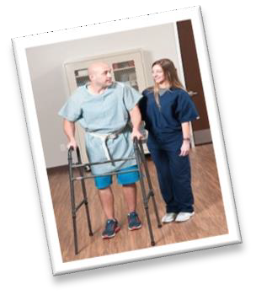
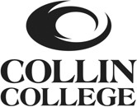

Where do Rehabilitation Aides work? Hospitals, Physical Therapy Outpatient Clinics, Sports Medicine Clinics, Chiropractic Clinics, Skilled Nursing Facilities, Rehabilitation Hospitals, Nursing Homes, etc.
Average Salary: $10-16/hour
Experience in the Rehabilitation Profession: Priceless
REHABILITATION AIDE OCCUPATIONAL SKILLS AWARD (OSA)
Interested in a career in:

If so, the Rehabilitation Aide OSA is for you! This program is designed to give an inside view to the world of rehabilitation and prepare students to work as a rehabilitation aide. Our program is a great start for anyone interested in the rehabilitation or physical/occupational therapy fields of study, or for anyone looking to jumpstart their career in the healthcare field.
What are the classes?  1st 8 weeks  PTHA 1201 The Profession of Physical Therapy PTHA 1409 Introduction to Physical Therapy 2nd 8 weeks  HPRS 2310 Basic Health Professions II PTHA 1160 Clinical Experience  The RA OSA is offered over 1 semester with 2- 8 week terms. | Course Details:  - Location: Frisco Campus  - For application information, visit www.collin.edu/department/phys icaltherapist Rehabilitation Aide OSA section of the website or contact Johanna Sandoval at jsandoval@collin.edu Applications accepted throughout the year.  Estimated Program Cost:
Why enroll in this program?
- To learn about careers in rehabilitation
- To springboard your career into rehabilitation
- To learn the skills as a PT aide/technician
- To prepare for entry into the PTA program
- To pursue a rewarding career
- To help patients
 |  | Tuition and fees | $644
 |  | Textbooks | $200
 |  | Estimated Total | $844
Certification Examination $109
*available to take near the end of the last semester, but not required

